CCC

New Generation Platform

IOP-DM1 AND FTC-DM1

Hardware Design Document
Rev-B

23rd April 2013

Ownership Disclaimer
This document contains proprietary and confidential material that is the sole property of Compressor Controls Corporation. The information contained herein is intended for internal use by Compressor Controls Corporation employees and is not intended for distribution outside of the company. As an unpublished work of trade secrets, the recipient shall keep this document confidential. Any re-use, copying, or distribution, either in whole or in part, of this material without the express written consent of Compressor Controls Corporation is strictly forbidden.
Copyright © 2011 by Compressor Controls Corporation. All rights reserved.

Revision History

Rev. | Date | Revised By | Change Description
0.9 | 22-SEP-2011 | Ajesh John | Initial Draft
1.0 | 23-SEP-2011 | Ajesh John | Updated with internal review comments
A | 18-FEB-2013 | Milish Joseph | Updated with comments as suggested by tom
B | 23-April-2013 | Milish joseph | Updated with comments as suggested by tom

Approvals

Approved by: Date: _______________

Table of Contents

1 Introduction 5
1.1 Purpose 5
1.2 Audience 5
1.3 Scope 5
1.4 Acronyms 5
1.5 References 5
2 General Description 6
2.1 Board features 6
2.2 Implementation block diagram 7
3 Description of functional Blocks 8
3.1 CPLD 8
3.2 Clock 8
3.3 EtherCAT Backplane Interface 8
3.4 Externally powered digital inputs 8
3.5 Internally powered digital inputs 9
3.6 Frequency inputs 10
3.7 Digital Outputs 11
3.8 Front Panel LEDs 12
3.9 Hot Swap Control 13
3.10 Power 14
3.11 Debug Support 16
3.12 Connectors 16
4 Schematic Design 28
4.1 Design Tool 28
5 Board Layout Design 28
5.1 Design Tool 28
5.2 Board Thickness 28
5.3 Board Stack-up 28

Introduction

Purpose
The purpose of this document is to describe the hardware design of IOP-DM1 card (I/O Mixed Digital card) and FTC-DM1 card. The IOP-DM1 board is used as I/O board for the processing the Digital mixed signals interfaced to the Field Termination Card (FTC-DM1) in New Generation Platform (NGP) control system.

Audience
The intended users of this document are hardware developers, software developers, test engineers, project leaders / program managers and management of Mindteck and Compressor Controls Corporation.

Scope
The document details the various functional level block diagrams. Also this document details about the board power budget analysis, any kind of mathematical / simulation analysis.

Acronyms
Acronym | Definition
FTC | Field Termination Cards
ESC | Ethernet slave controller
IOP | Input Output Processor
DM | Digital Module

References
[1] Detailed Functional Specification for NGP Hardware, Part 1, Rev-3
[2] System Study for New Generation Platform Electronics and Bring-up, Rev-1

General Description

Board features

IOP-DM1 card has the following features

- Freescale processor MPC5534 based daughter board.
- MAX II CPLD 2210 Logic elements with 204 I/O’s support.
- Ether-CAT (ET1100) bus communications.
- Supports general board diagnostics (Voltage, temperature)
- Hot-swap capability
- Development / test port facility (JTAG, Nexus, logic analyzer etc)

IOP-DM1 card with FTC-DM board provide following features

- 8 Internally powered Digital inputs
  - Isolated with respect to rest of the system- ie CPLD and MPC5534 board and other boards in the backplane(APP,IES,PCC and CAC cards)
  - Has diagnostic capability- ie board has necessary circuit for detecting if any fault has occurred in the circuit.
  - Self testing capability- has circuits for checking the condition of digital input channels
- 2 Internally powered Digital inputs
  - Isolated with respect to rest of the system- ie CPLD and MPC5534 board and other boards in the backplane(APP,IES,PCC and CAC cards)
- 3 Frequency inputs
  - Isolated with respect to rest of the system- ie CPLD and MPC5534 board and other boards in the backplane(APP,IES,PCC and CAC cards)
- 10 Digital Outputs
  - Isolated with respect to rest of the system- ie CPLD and MPC5534 board and other boards in the backplane(APP,IES,PCC and CAC cards)
  - Has diagnostic capability- ie board has necessary circuit for detecting if any fault has occurred in the circuit.

Implementation block diagram
The Implementation block diagram for the IOP-DM1 card is shown below.
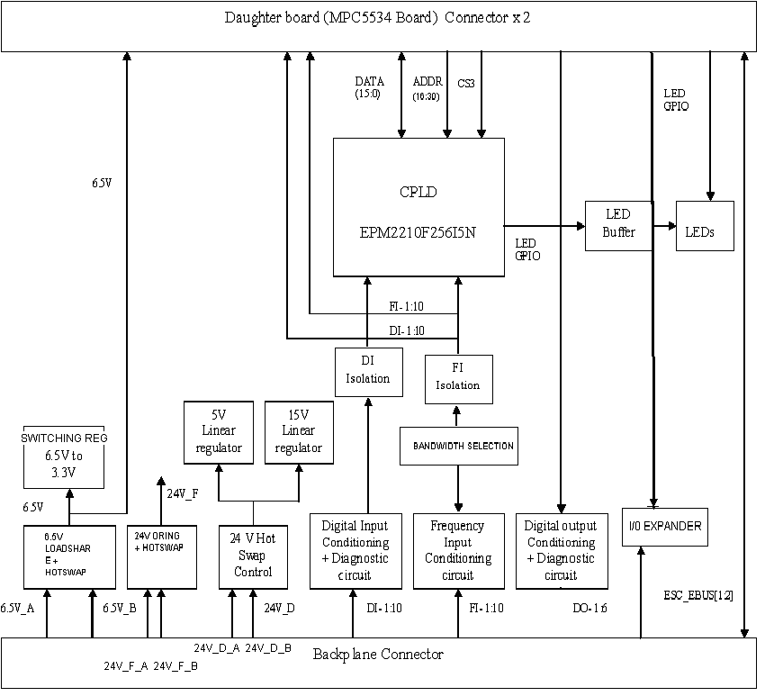

Description of functional Blocks

CPLD
The IOP DM1 board is using EPM2210F256I5N from Altera as the CPLD. It is accessible to MPC5534 through the external bus interface chip select3. The CPLD runs with a frequency of 40MHz. The clock is supplied to the CPLD from an external oscillator.

Functions of CPLD
- Controlling of Front panel LEDs
- Controlling of the DAC whose o/p is going to Digital input channels
- Controlling the serial shift register which is controlling digital input channel switch
- Communicate with MPC5534 through parallel 14-bit address and 16-bit data.

Clock
The CPLD shall be provided an external clock with a frequency of 40MHz.

EtherCAT Backplane Interface
The IOP routes signals from two EherCat ports in MPC5534 board to the IES through the backplane connector.

Externally powered digital inputs
The externally powered digital input channels are applied from an external power source. These signals are just routed to the IOP Board through the FTC board.
The externally powered digital inputs coming from the FTC board are applied to an Optocoupler in the IOP Board. The optocopler gives a logic low ouput if the input is present and a high output if the input is not present. This signal is given to MPC5534 board through an inverting buffer.

IOP Board

FTC
Board
OPTOCOUPLER
INVERTING BUFFER
OPTOISOLATED OUTPUT
To MPC5534 Board
Externally powered
Digital input

Internally powered digital inputs
The implementation block diagram for processing the internally powered digital inputs is shown below.

FTC Board



IOP Board
OPTOCOUPLER
INVERTING BUFFER
Externally powered
Digital input
Filter
Circuits

Analog Switch
COMPARATOR

Control Signals
To MPC5534 Board

Serial Self Test Switch
(Shift register)
DAC+ AMPLIFIER

Digital
Isolator
Digital
Isolator

Serial interface
Serial interface

CPLD

Filter circuits

The filter circuits are provided in the FTC board to suppress the noise associated with these input channels.

Analog Switch

The Analog Switch switches the input voltage signals coming from the FTC board to rest of the digital input monitoring circuits in IOP Board based on the signals coming from Serial self test switch.

Serial self test switch

The serial self test switch controls the position of the analog switch based on the data it is getting from the CPLD through serial interface. The serial shift register controls the analog switch channels based on the status of signals called CH_DIAG_EN & CH1_DIAG_ACT.

CH_DIAG_EN | CH1_DIAG_ACT | Analog switch output
0 | 0 | Signal coming from FTC
1 | 0 | 5V for testing the testing operating condition of analog switch
1 | 1 | 24V for testing the testing operating condition of analog switch

Comparator

The comparator compares the voltage coming from the output of analog switch to the reference voltage coming from the DAC and amplifier.

The output from the comparator is given to the MPC5534 in Daughter board through an optocoupler and an inverter. The MPC5534 determines the status of the digital channel based on the data it is transferred to the DAC and self test switch registers.

Frequency inputs

This signal is given to MPC5534 board through an inverting buffer.

IOP Board

FTC
Board
OPTOCOUPLER
INVERTING BUFFER
To MPC5534 Board
Filter+ Zener Diodes
COMPARATOR
Externally Frequency input

The incoming differential frequency input is filtered and scaled down using zener diodes and fed to voltage comparator in the IOP Board. The comparator produces a square waveform of the same frequency as the input voltage waveform. This square waveform is fed to an Optocoupler and the optocoupler produces an inverted square waveform This signal is given to MPC5534 board through an inverting buffer for reading the frequency.
The frequency section is provided with adjustable bandwidth selection . The bandwidth can be selected by selecting different values for resisters and capacitors through an analog switch as shown below

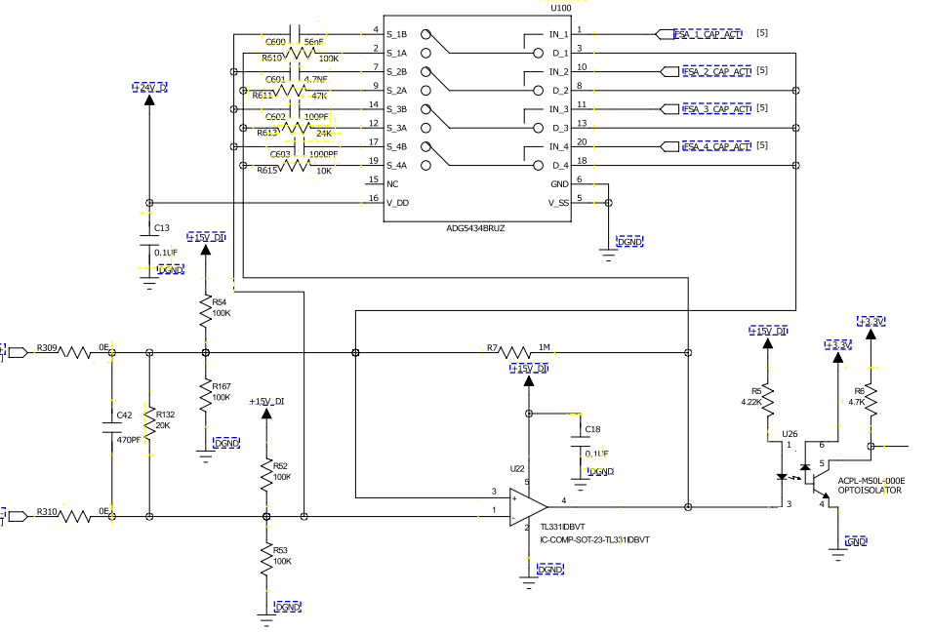

Digital Outputs

IOP Board

FTC Board
Digital Output circuits’ Control Signal from MPC5534 board
Digital Output enable circuit

Output channel control
Relay
Output channel Control Signal from MPC5534 board

Low side output
Switch
Output channel control
Relay
Output channel
Relay

Digital Output
Diagnostic Circuit

DO_RD_BCK3_IOP

DO_RD_BCK2_IOP
DO_RD_BCK1_IOP
CPLD

Each output has a single relay located on the FTC with its three contacts routed to a terminal block. Each IOP has a low side switch and relay that are connected in series to the output relay coil. The low side switch is controlled by the output State signal from the MPC5534.
The control signal coming from the Digital output enable circuit controls the IOP channel relay. This control signal is generated by the healthy CPLD in the MPC5534 board.

The IOP DM board employs diagnostic circuits for detecting the status of the digital output channels. Based on the status of the output signals(viz DO_RD_BCK1_IOP DO_RD_BCK2_IOP DO_RD_BCK3_IOP) coming from the diagnostic circuit, we will know the condition of that output channel. This is shown in following table.

DO_RD_BCK1_IOP | DO_RD_BCK2_IOP | Analog switch output
0 | 0 | FTC not connected, FTC relay coil burnt
1 | 1 | IOP relay de-energized

DO_RD_BCK3_IOP | Analog switch output
0 | FTC relay energised
1 | FTC relay de-energised

Front Panel LEDs

The IOP Board implements following LEDs in the front panel.

Name |  | Function |  | Color
POWER |  | Power Supply(ies) status ok |  | Blue-CCC
ACTIVE |  | Card is controlling output channels |  | Green
READY |  | Card is healthy and has no detectable faults |  | Green
ALARM |  | Card has a detectable non-critical issue |  | Yellow
FAULT |  | Card has a critical error |  | Red
CPU |  | CPU is active/heartbeat |  | Green
LEARN |  | Card in initializing/booting/learning from peer |  | Green
ESC1 Link/activity |  | Indicates the Link/activity status for ESC1 |  | Green
ESC2 Link/activity |  | Indicates the Link/activity status for ESC2 |  | Green
ESC1 Run |  | Indicates the RUN status for ESC1 |  | Green
ESC2 Run |  | Indicates the RUN status for ESC2 |  | Green
DI1 | Indicates the status of Digital input 1 |  | Green/Red
DI2 | Indicates the status of Digital input 2 |  | Green/Red
DI3 | Indicates the status of Digital input 3 |  | Green/Red
DI4 | Indicates the status of Digital input 4 |  | Green/Red
DI5 | Indicates the status of Digital input 5 |  | Green/Red
DI6 | Indicates the status of Digital input 6 or Frequency input signal 1 |  | Green/Red
DI7 | Indicates the status of Digital input 7 or Frequency input signal 2 |  | Green/Red
DI8 | Indicates the active status of Digital input 8 or Frequency input signal 3 |  | Green/Red
DI9 | Indicates the status of Digital input 9 |  | Green/Red
DI10 | Indicates the status of Digital input 10 |  | Green/Red

The LEDs showing the status of Digital inputs and Digital outputs are controlled from CPLD. These LEDs can be driven by MPC5534 by passing information to the CPLD through EBI interface or as CPLD stand alone.

The LEDs used for denoting status of LEDs are bicolor LEDs. They will show green if that channel is active and red if there is some fault with the channel.

The LEDs other than that for the Digital inputs and Digital outputs are directly controlled by MPC5534 board.

Hot Swap Control
A hot-swap circuit is used to make this board ready for live insertion and removal in the system . The hot swappable feature is mad available for all the power signals (24V_D, 24V_F, 6.5V)

Power
Power delivery diagram for the IOP Board is shown below.

B
A
C
K
P
L
A
N
E

C
O
N
N
E
C
T
O
R
HotSwap +
Load share
6.5V_A
3.3V REGULATOR
6.5V
3.3V

6.5V_B

ORING CIRCUIT
+
HOTSWAP

24V_F
24V_F_B

24V_D ORING + HOTSWAP

15V LDO
5V LDO

Power distribution in FTC-DM

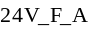
24V_D_A_IOPA
24V_D_A_IOPB
24V_D_B_IOPA
24V_D_B_IOPB
24V_F_B
Diode Oring Circuit

24V_F

Diode Oring Circuit
B
A
C
K
P
L
A
N
E

C
O
N
N
E
C
T
O
R
24VD_A
24VD_B
24V_D
Board Power Requirement:
Sr No | Qty | Reference number | Component | Voltage (V) | Typical Current (mA) | Total Current (mA)
3.3V Requirement
1 | 2 | U13-14 U88 | ADUM3400CRWZ-RL | 3.3 | 5 | 10
2 | 18 |  | RES pull ups 1K at DO channels | 3.3 | 0.022 | 0.396
3 | 6 |  | RES pull ups 10K at FTC read back channels | 3.3 | 0.33 | 1.98
4 | 1 | Y1 | 632L3I040M00000 | 3.3 | 15 | 15
5 | 2 | U9,U25 | SN74LVC14ADGVR | 3.3 | 5 | 10
6 | 3 | U71 U74-75 | 74LVC1G14GW | 3.3 | 0.2 | 0.6
7 | 3 | U61, U63, U64 | SN74LVC1G97QDCKRQ1 | 3.3 | 0.5 | 1.5
8 | 2 | U30, U66 | 74LCX02MTCX | 3.3 | 5 | 10
9 | 1 | U62 | CAT25160 | 3.3 | 2 | 2
10 | 1 | U17 | EPM2210F256 | 3.3 | 50 | 50
11 | 3 | U82 U97-98 | SN74LVC1G32DRLR | 3.3 | 0.5 | 1.5
12 | 1 | U16 | MCP23S17-E/SS | 3.3 | 1 | 1
13 | 25 | D9-24 D25 D28 D26 D29 D30 D8 D37 | LED | 3.3 | 4 | 100
14 | 2 | U65,U72 | CLVC1G125MDCKREP | 3.3 | 1 | 2
15 | 2 | U69,U70 | lP2901 | 3.3 | 1 | 2
Total |  |  |  |  |  | 207.976
6.5V Requirement
1 | 4 | D44,D39,D64,D41 | Single LEDs | 6.5 | 8 | 32
2 | 1 | R23 | resisitor divider circuit | 6.5 | 6.5 | 6.5
3 |  |  | 3.3v power rail |  |  | 207.976
4 | 1 | U122 | LTC4210-1IS6#TRMPBF | 6.5 | 0.65 | 0.65
Total |  |  |  |  |  | 247.126
24V_F Requirement
1 | 6 | U4 U6 U8 U12 U15 U20 | lP2901 | 24 | 1 | 6
2 | 7 | K1-7 | EF2-24NU | 24 | 2 | 14
3 | 1 | U68 | LT4256-3IGN#PBF | 24 | 1.8 | 1.8
Total |  |  |  |  |  | 21.8
5V_D Requirement
1 | 1 | U49 | DAC088S085 | 5 | 2.5 | 2.5
2 | 4 | U55-56 U86-87 | MM74HC595 | 5 | 0.2 | 0.8
3 | 3 | U13-14 U88 | ADUM3400CRWZ-RL | 2 | 6 | 18
Total |  |  |  |  |  | 21.3
15V_D Requirement
1 | 1 | U22,U76,U79 | TL331IDBVT | 15 | 2.5 | 2.5
2 | 3 | R5, R9, R29 | 4.22k | 15 | 3 | 9
3 | 3 | U26, U28, U58 | ACPL-M50L-000E | 15 | 2 | 6
Total |  |  |  |  |  | 17.5
24V_D Requirement
1 | 4 | U50, U52, U53, U54 | OPA2209AIDR | 24 | 3 | 12
2 | 2 | U38, U39 | LM2901 | 24 | 2 | 4
3 | 3 | U27 U81 U92 | LM2903 | 24 | 2.5 | 7.5
4 | 8 | U40, U41, ......U48 ,U83,U93 | ACPL-M50L-000E | 24 | 7 | 56
5 | 4 | U34, U35, U36, U37 | ADG5534 | 24 | 1 | 4
5 | 4 | U34, U35, U36, U37 | ADG5534 | 24 | 1 | 4
6 |  |  | 15V_D power rail |  |  | 17.5
7 |  |  | 5V_D power rail |  |  | 21.3
Total |  |  |  |  |  | 126.3

Debug Support
JTAG Header:

The JTAG header is provided for the programming of the CPLD in IOP Board and the CPLD in MPC5534 board.

Manual Reset Switch:

There is a manual switch (SW1) provided on board to reset the board. Whenever it is pressed (activated), MPC5534 gets reset which in turn generates the reset the CPLD in IOP Board as well .

Test Points/ Jumpers:

Test points are provided for probing important signals, power and ground nets during debugging/ testing.

Connectors

    - IOP – DM1 to Backplane
Make | Part No | Description
FCI | 10045267-111LF | 72-PIN Air-Max
FCI | 10061289-001LF | 6-PIN Power connector
FCI | 10045597-105LF | GUIDE PIN

    - IOP-DM1 to MPC5534 Daughter board
Make | Part No | Description
Samtec | QTE-040-02-X-D-A | 80-PIN,Male Shroud Contacts

    - FTC – DM1 to Backplane
Make | Part No | Description
FCI | 10056098-1050011LF | 150-PIN Air-Max

    - FTC – DM1- Terminal Blocks

Make | Part No | Description
FCI | MSTBV 2,5/18-GF-5,08-1777235 | 12-PIN Terminal block

    - Backplane connector signals

Backplane Connector Pins Naming on IOP-DM1
Connector 1 : REFDES J5
Pin No. | Name |  | Description
A3
A5
A7
B1 | DGND |  | Digital ground
B3
B5
B7
C1 | DGND |  | Digital ground
C3
C5
C7
D1 | +24V_D_B |  | 24V digital B
D3
D5 | DI_10- |  | digital input 10 -ive (external)
D7 | FQ3- |  | Frequency input 3 -ve
E1
E3
E5 | DI_10+ |  | digital input 10 +ve (external)
E7 | FQ3+ |  | Frequency input 3 +ve
F1
F3
F5
F7
G1
G3
G5 | DI_4 |  | Digital input 4 (internal)
G7 | DI_8 |  | Digital input 8 (internal)
H1
H3
H5 | DI_3 |  | Digital input 3 (internal)
H7 | DI_7 |  | Digital input 7 (internal)
I1
I3
I5
I7
A2 | +24V_D_A |  | 24V digital A
A4
A6
A8
B2 | DGND |  | Digital ground
B4
B6
B8
C2 | DGND |  | Digital ground
C4
C6
C8
D2 | +24V_D_B |  | 24V digital B
D4
D6
D8
E2
E4 | 6.5V_HOT_SWAP_ENABLE |  | HOT SWAP ENABLE PIN
E6 | DI_9+ |  | digital input 9 +ive (external)
E8 | FQ2+ |  | Frequency input 2 +ve
F2
F4
F6 | DI_9- |  | digital input 9 -ive (external)
F8 | FQ2- |  | Frequency input 2 -ve
G2
G4
G6
G8
H2
H4 | DI_1
H6 | DI_5 |  | Digital input 5 (internal)
H8 | FQ1- |  | Frequency input 1 -ve
I2
I4 | DI_2 |  | Digital input 2 (internal)
I6 | DI_6 |  | Digital input 6 (internal)
I8 | FQ1+ |  | Frequency input 1 +ve
Connector 1 : REFDES J4
Pin No. | Name | Description
A1
A2
A4
A6
A8 | FTC_BD5 | FTC BOARD ID 5
B1
B2
B4
B6
B8
C1
C2
C4
C6
C8
D1
D2
D4
D6
D8 | DO5_FTC_RD_BK_B | Digital output 5 read back to iop-dmB
E1
E2
E4
E6
E8 | DO6_FTC_RD_BK_B | Digital output 6 read back to iop-dmB
F1
F2
F4
F6
F8
G1
G2
G4 | DI_2 | Digital input 2 (internal)
G6 | FI3+ | Frequency input 3 +ve
G8 | DO_2+_B | Digital output 5 read back to iop-dmB
H1
H2
H4 | DI_1 | Digital input 1 (internal)
H6 | FI3- | Frequency input 3 -ve
H8 | DO_1+_B | Digital output 1 read back to iop-dmB
I1
I2
I4
I6
I8
J1
J2
J4
J6 | DI_8 | Digital input 8 (internal)
J8
K1
K2
K4
K6 | DI_7 | Digital input 7 (internal)
K8 | DI_FREQ_SEL3_B | Digital i/p 8 or Freq i/p 3 select signal from IOP Board B
L1 | 24VD_B_IOPB
L2 | 24VD_B_IOPB
L4
L6
L8
M1 | GND-D | digital ground
M2 | GND-D | digital ground
M4 | TB_DI10+ | digital input 10 +ive (external)
M6
M8
N1 | GND-D | digital ground
N2 | GND-D | digital ground
N4 | TB_DI10- | digital input 10 -ive (external)
N6
N8
O1 | 24VD_A_IOPB
O2 | 24VD_A_IOPB
O4
O6
O8
A10 | FTC_BD1 | FTC BOARD ID 1
A3
A5
A7 | GND-F | ground
A9 | FTC_BD3
B10 | FTC_BD2
B3
B5
B7 | GND-F | ground
B9 | FTC_BD4 | FTC BOARD ID 4
C10
C3
C5
C7
C9
D10 | DO4_OWD_B | Output Channel 4: open wire detect signal to iop-dmB
D3
D5
D7
D9
E10 | DO3_OWD_B | Output Channel 3: open wire detect signal to iop-dmB
E3
E5 | DI_4 | Digital input 4 (internal)
E7 | FI2+ | Frequency input 2 +ve
E9
F10
F3
F5 | DI_3 | Digital input 3 (internal)
F7 | FI2- | Frequency input 2 -ve
F9
G10 | DO3_FTC_RD_BK_B | Digital output 3 read back to iop-dmB
G3
G5
G7
G9
H10 | DO4_FTC_RD_BK_B | Digital output 4 read back to iop-dmB
H3
H5
H7 | FI1+ | Frequency input 1 +ve
H9 | DI_FREQ_SEL2_B | Digital i/p 7 or Freq i/p 2 select signal from IOP Board B
I10
I3
I5
I7 | FI1- | Frequency input 1 -ve
I9 | DI_FREQ_SEL1_B | Digital i/p 6 or Freq i/p 1 select signal from IOP Board B
J10 | DO2_FTC_RD_BK_B | Digital output 2 read back to iop-dmB
J3
J5
J7
J9
K10 | DO1_FTC_RD_BK_B | Digital output 1 read back to iop-dmB
K3
K5 | TB_DI9+ | digital input 9 +ive (external)
K7 | DO_5+_B | Digital output 5 read back to iop-dmB
K9 | DO5_OWD_B | Output Channel 5: open wire detect signal to iop-dmB
L10
L3
L5 | TB_DI9- | digital input 9 -ive (external)
L7 | DO_6+_B | Digital output 6 read back to iop-dmB
L9 | DO6_OWD_B | Output Channel 6: open wire detect signal to iop-dmB
M10
M3
M5
M7
M9
N10
N3
N5 | DI_6 | Digital input 6 (internal)
N7 | DO_4+_B | Digital output 4 read back to iop-dmB
N9 | DO2_OWD_B | Output Channel 2: open wire detect signal to iop-dmB
O10
O3
O5 | DI_5 | Digital input 5 (internal)
O7 | DO_3+_B | Digital output 3 read back to iop-dmB
O9 | DO1_OWD_B | Output Channel 1: open wire detect signal to iopdmB
Connector 1 : REFDES J1
Pin No. | Name |  | Description
A1 | 24VF_A |  | 24V filtered A
A2 | 24VF_B |  | 24V filtered B
A4 | GND-F |  | ground
A6 | 24VD_B |  | 24V digital B
A8 | GND-D |  | digital ground
B1 | 24VF_A |  | 24V filtered A
B2 | 24VF_B |  | 24V filtered B
B4 | GND-F |  | ground
B6 | 24VD_B |  | 24V filtered B
B8 | GND-D |  | digital ground
C1
C2
C4
C6
C8
D1
D2
D4
D6
D8
E1
E2 | DI_4 |  | Digital input 4 (internal)
E4 | FI2+ |  | Frequency input 2 +ve
E6
E8
F1
F2 | DI_3 |  | Digital input 3 (internal)
F4 | FI2- |  | Frequency input 2 -ive
F6
F8
G1 | DI_2 |  | Digital input 2 (internal)
G2
G4
G6
G8
H1 | DI_1 |  | Digital input 1 (internal)
H2
H4 | FI1+ |  | Frequency input 1 +ve
H6 | DI_FREQ_SEL2_A |  | Digital i/p 7 or Freq i/p 2 select signal from IOP Board A
H8
I1
I2
I4 | FI1- |  | Frequency input 1 -ve
I6 | DI_FREQ_SEL1_A |  | Digital i/p 6 or Freq i/p 1 select signal from IOP Board A
I8
J1
J2
J4
J6
J8
K1
K2 | TB_DI9+ |  | digital input 9 +ive (external)
K4 | DO_5+_A |  | Digital output 5 control
K6 | DO5_OWD_A |  | Output Channel 5: open wire detect signal
K8
L1
L2 | TB_DI9- |  | digital input 9 -ive (external)
L4 | DO_6+_A |  | Digital output 6 control to iop-dm A
L6 | DO6_OWD_A |  | Output Channel 6: open wire detect signal to iop-dmA
L8
M1 | TB_DI10+ |  | digital input 10 +ive (external)
M2
M4
M6
M8
N1 | TB_DI10- |  | digital input 10 -ive (external)
N2 | DI_6 |  | Digital input 6 (internal)
N4 | DO_4+_A |  | Digital output 4 control to iop-dm A
N6 | DO2_OWD_A |  | Output Channel 2: open wire detect signal to iop-dmA
N8
O1
O2 | DI_5 |  | Digital input 5 (internal)
O4 | DO_3+_A |  | Digital output 3 control to iop-dm A
O6 | DO1_OWD_A |  | Output Channel 1: open wire detect signal to iop-dmA
O8
A10 | GND-D |  | digital ground
A3 | GND-F |  | ground
A5
A7 | 24VD_B |  | 24V digital B
A9 | GND-D |  | digital ground
B10 | GND-D |  | digital ground
B3 | GND-F |  | ground
B5
B7 | 24VD_B |  | 24V_D B
B9 | GND-D |  | digital ground
C10 | GND-D |  | digital ground
C3
C5
C7
C9 | GND-D |  | digital ground
D10 | 24VD_A |  | 24V digital A
D3
D5 | DO5_FTC_RD_BK_A |  | Digital output 5 read back to iop-dmA
D7 | DO4_OWD_A |  | Output Channel 4: open wire detect signal to iop-dmA
D9 | 24VD_A |  | 24V digital A
E10 | 24VD_A |  | 24V digital A
E3
E5 | DO6_FTC_RD_BK_A |  | Digital output 6 read back to iop-dmA
E7 | DO3_OWD_A |  | Output Channel 3: open wire detect signal to iop-dmA
E9 | 24VD_A |  | 24V digital A
F10
F3
F5
F7
F9
G10 | 24VD_B_IOPA
G3 | FI3+ |  | Frequency input 3 +ve
G5 | DO_2+_A |  | Output Channel 2: open wire detect signal to iop-dmA
G7 | DO3_FTC_RD_BK_A |  | Digital output 3 read back to iop-dmA
G9 | 24VD_B_IOPA
H10 | GND-D |  | digital ground
H3 | FI3- |  | Frequency input 3 -ve
H5 | DO_1+_A |  | Output Channel 1: open wire detect signal to iop-dmA
H7 | DO4_FTC_RD_BK_A |  | Digital output 4 read back to iop-dmA
H9 | GND-D |  | digital ground
I10 | GND-D |  | digital ground
I3
I5
I7
I9 | GND-D |  | digital ground
J10 | 24VD_A_IOPA
J3 | DI_8 |  | Digital input 8 (internal)
J5
J7 | DO2_FTC_RD_BK_A |  | Digital output 2 read back to iop-dmA
J9 | 24VD_A_IOPA
K10
K3 | DI_7 |  | Digital input 7 (internal)
K5 | DI_FREQ_SEL3_A |  | Digital i/p 8 or Freq i/p 3 select signal from IOP Board A
K7 | DO1_FTC_RD_BK_A |  | Digital output 1 read back to iop-dmA
K9
L10
L3
L5
L7
L9
M10
M3
M5
M7
M9
N10
N3
N5
N7
N9
O10
O3
O5
O7
O9
Connector 1 : REFDES J2
Pin No. | Name |  |  | Description
A1 | DO_5+ |  |  | Digital output 5 control
A3
A5 | DO4_FTC_RD_BK |  |  | Digital output 4 read back
A7 | ESC1_EBUS[0]-TX- |  |  | transmit data from IES-A -ve
B1 | DO_6+ |  |  | Digital output 6 control
B3
B5 | DO3_FTC_RD_BK |  |  | Digital output 3 read back
B7 | ESC1_EBUS[0]-TX+ |  |  | transmit data from IES-A +ve
C1
C3
C5 | IOP_SLOT_ID4 |  |  | slot id 4
C7 | GND |  |  | ground
D1 | DO_3+ |  |  | Digital output 3 control
D3 | DI_FREQ_SEL1_FTC |  |  | Digital i/p 6 or Freq i/p 1 select signal from IOP Board A
D5 | DO2_FTC_RD_BK |  |  | Digital output 2 read back
D7 | PEER_READY_FB
E1 | DO_4+ |  |  | Digital output 4 control
E3 | DI_FREQ_SEL2_FTC |  |  | Digital i/p 7 or Freq i/p 2 select signal from IOP Board A
E5 | DO1_FTC_RD_BK |  |  | Digital output 1 read back
E7 | IOP_TO_IOP_SHR3
F1
F3 | CHASSIS_NO1 |  |  | chassis id 1
F5 | CHASIS_NO4 |  |  | chassis id 4
F7 | CONTROL_FB_B
G1 | DO5_FTC_RD_BK |  |  | Digital output 5 read back
G3 | DO5_OWD |  |  | Output Channel 5: open wire detect signal
G5
G7 | ESC2_EBUS[0]-TX- |  |  | Transmit data to IES-B -ive
H1 | DO6_FTC_RD_BK |  |  | Digital output 6 read back
H3 | DO6_OWD |  |  | Output Channel 6: open wire detect signal
H5
H7 | ESC2_EBUS[0]-TX+ |  |  | Transmit data to IES-B +ive
I1
I3 | IOP_SLOT_ID1 |  |  | slot id 1
I5 | ANB |  |  | iop A or iop B selection
I7 | GND |  |  | ground
A2
A4 | IOP_SLOT_ID2 |  |  | slot id 2
A6 | BACKPLANE_TYPE1 |  |  | backplane id 1
A8 | GND |  |  | ground
B2 | DO_1+ |  |  | Digital output 1 control
B4 | DO1_OWD |  |  | Output Channel 1: open wire detect signal
B6 | BACKPLANE_TYPE2 |  |  | backplane id 2
B8 | ESC1_EBUS[0]-RX- |  |  | Receive data from IES-A -ive
C2 | DO_2+ |  |  | Digital output 2 control
C4 | DO2_OWD |  |  | Output Channel 2: open wire detect signal
C6 | BACKPLANE_TYPE3 |  |  | backplane id 3
C8 | ESC1_EBUS[0]-RX+ |  |  | Receive data from IES-A +ive
D2
D4 | IOP_SLOT_ID3 |  |  | slot id 3
D6 | BACKPLANE_TYPE4 |  |  | backplane id4
D8 | READY_FB_B
E2
E4 | +6.5V_LOAD-SHARED
E6 | FTC_BD1 |  |  | FTC id 1
E8 | IOP_TO_IOP_SRH2
F2 | DI_FREQ_SEL3_FTC |  |  | Digital i/p 8 or Freq i/p 3 select signal from IOP Board A
F4 | CHASSIS_NO2 |  |  | chassis id 2
F6 | FTC_BD2 |  |  | FTC id 2
F8 | PEER_CONTROL_FB
G2
G4 | CHASSIS_NO3 |  |  | chassis id 3
G6 | FTC_BD3 |  |  | FTC id 3
G8 | GND |  |  | ground
H2
H4 | DO4_OWD |  |  | Output Channel 4: open wire detect signal
H6 | FTC_BD4 |  |  | FTC id 4
H8 | ESC2_EBUS[0]-RX- |  |  | Receive data from IES-B -ive
I2
I4 | DO3_OWD |  |  | Output Channel 3: open wire detect signal
I6 | FTC_BD5 |  |  | FTC id 5
I8 | ESC2_EBUS[0]-RX+ |  |  | Receive data from IES-B +ive

Schematic Design

Design Tool
Schematic entry is done in PAD9.3

Board Layout Design

Design Tool
Layout design is done in PAD9.3

Board Thickness
Thickness of the Board designed is 1.6mm±10% [0.063” ± 10%]

Board Stack-up
The IOP Board is designed with six layer PCB stack-up. The PCBlayer is shown below.

